HEADACHE CALENDAR

Name: ______________________ DOB: ______________

Month: ___________________ Year: _________

Headache Severity: This calendar is numbered 1-31 for each day of the month. On the days that you have headache pain, record in the box with the corresponding number for the day of the month the level of pain intensity: 1 = mild, 2 = moderate, 3 = severe
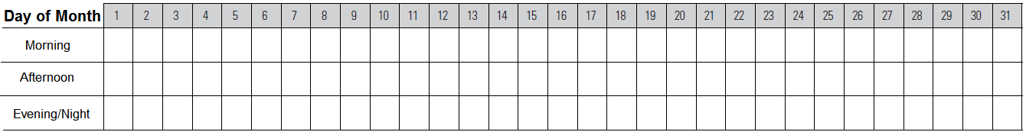

Disability: Write a number from 0 to 3 that describes how your headache pain affected your daily activities: 0 = no effect; 1 = able to carry out your activities fairly well; 2 = you had difficulty with usual activities & cancelled less important ones; 3 = you missed work/school for at least half the day or stayed in bed for part of the day.

Triggers: Each trigger has been assigned a number. Record the numbers of the trigger(s) you may have been exposed to on the day of your headache,

Menstrual Periods: Place an X on the days you have had your period.
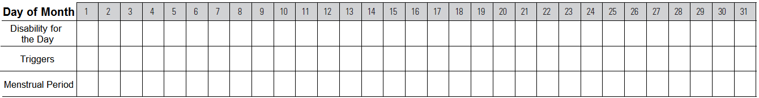

Acute Medicines (Medicines taken to treat headaches and related symptoms): On the days you have taken medicine(s) to relieve your headache pain, write the names and dosage of the medications in the appropriate boxes below. Please a  for each day you have taken on the corresponding date. Also, record in the appropriate box a number from 0 to 3 that describes the amount of overall relieve you received from the medicine: 0 = no relief; 1 = slight relief; 2 = moderate relief; 3 = complete relief
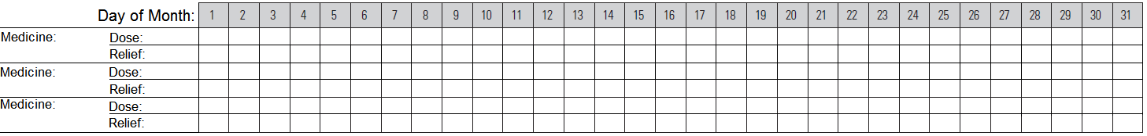

Preventative Medicines (Medicines taken to prevent headaches and related symptoms): If your doctor has prescribed any preventative medicine(s) for you, write the names and dosage of the medications in the appropriate boxes below. Please a  for each day you have taken on the corresponding date.
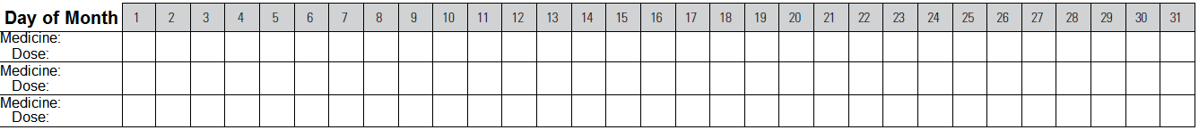

Overall Severity for this month: (Circle one number):
0 1 2 3 4 5 6 7 8 9 10

